1. Generate the following content with Pseudo-elements and css (Green is the annotation content, no need to implement)：

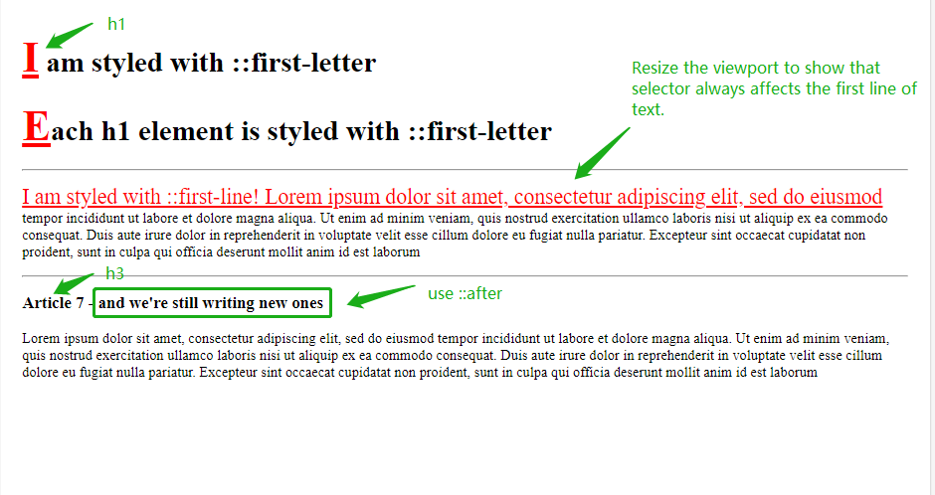

Reference answer: **Pseudo-elements and css 01.html**

2. Generate the following content with Pseudo-elements and css (Green is the annotation content, no need to implement)：

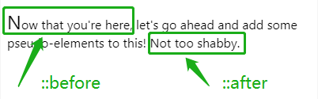

Reference answer: **Pseudo-elements and css 02.html**

3. Generate the following content with Pseudo-elements and css (Red and green use pseudo-elements):

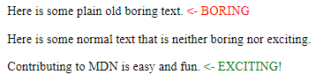

Reference answer: **Pseudo-elements and css 03.html**

4. Generate the following content with Pseudo-elements and css:

C:\Users\Lily\AppData\Local\Temp\1652335584(1).png

Reference answer: **Pseudo-elements and css 04.html**

5. Generate the following content with Pseudo-elements and css:

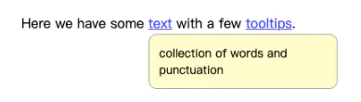

Reference answer: **Pseudo-elements and css 05.html**